




Mini Project Report On

DRC ASSOCIATES WEBSITE USING HTML & CSS

SUBMITTED BY: SUBMITTED TO:
NAME: NISHANT KUMAR SINGH Ms. MANSIRAT KAUR
UID: 26MCA20023 Assistant Professor
CLASS: MCA GENERAL
SECTION:1(A)

Table of Content

S. No. | Name | Page no.
1 | Acknowledgement | 3
2 | Introduction /Background | 4
3 | Objective/ Technologies Used | 4
4 | Technologies Used | 4
5 | Requirements and System Design | 5-6
6 | Source Code & Output | 7-9
7 | Functionalities | 10
8 | Conclusion/Future Work/Learning Outcomes | 11-12

Acknowledgement
I would like to express my sincere gratitude to my faculty and instructors for their guidance and support during the development of this mini project, “DRC & Associates Website (Dark Theme).” Their suggestions helped me understand the web design concepts required to complete this project.
I am also thankful to my classmates and friends who provided useful feedback during testing.
Their support helped me identify and correct layout and design issues in the pages.
I would like to acknowledge the developers of HTML and CSS and the tools used for writing and previewing the website.
These tools made it possible to practise web development concepts in a simple and practical way.
This project has helped me improve my understanding of HTML, CSS and how a responsive, dark-themed website can be built using only these two technologies.

Introduction
The DRC & Associates website is a simple multi-page, dark-themed website developed using HTML and CSS. It presents an accounting, tax and business consultancy firm through a Home page, a Services page and a Contact page that are connected by a common navigation menu.
The website is designed for learning and demonstration purposes. It shows how semantic HTML, a shared CSS file, CSS variables, Flexbox and Grid can be combined to build a professional-looking interface. It does not use JavaScript, does not connect to a server and does not store any visitor data.

Background
Accounting and tax consultancy firms need a clear online presence where visitors can learn about the services offered and find a way to make an enquiry. This project presents a simplified website for a fictional firm, DRC & Associates. A single stylesheet (style.css) defines a compact dark colour scheme with teal and gold accents that is reused across all three pages. The pages run in any modern browser without installation.

Objectives
- To design a multi-page website using HTML5 and CSS3.
- To understand semantic tags, links, lists, forms and page structure.
- To apply a dark colour theme using CSS variables.
- To use Flexbox and CSS Grid for responsive page layouts.
- To create reusable styles for the header, cards, buttons, forms and footer.
- To make the website adapt to tablet and mobile screens using media queries.

Technologies Used

- Markup Language: HTML5
- Styling Language: CSS3 (variables, Flexbox, Grid, media queries)
- Code Editor: Visual Studio Code (Live Server extension optional)
- Browser: Google Chrome, Microsoft Edge or Mozilla Firefox
- Interface: Static, browser-based user interface (no JavaScript)

Requirements
  - Software Requirements
        - Operating System: Windows, Linux or macOS.
        - Web Browser: Chrome, Edge, Firefox or any modern browser.
        - Code Editor: Visual Studio Code or any text editor.
        - Optional: Live Server extension to preview the website.

5.2 Hardware Requirements
        - A computer or laptop capable of running a modern web browser.
        - Keyboard, mouse and display.
        - Basic memory and storage sufficient for the editor and browser

System Design
6.1 Architecture Overview
The website follows a simple multi-page static architecture. Each HTML file (index.html, services.html and contact.html) contains the same header and footer and links to one shared stylesheet, css/style.css. The visitor uses the navigation menu to move between pages.
The browser renders every page with the common styles, so a change in style.css updates the whole website.

Browser → HTML Page → css/style.css → Rendered Dark-Theme Page

6.2 Module Overview
          - Home Page (index.html): Hero section, overview card, About section and call-to-action.
          - Services Page (services.html): Six service cards and an important disclaimer.
          - Contact Page (contact.html): Sample contact details and a demo enquiry form.
          - Stylesheet (css/style.css): Dark theme variables, layout, components and responsive rules.
          - README.txt: Instructions to run the website and notes about the demonstration.

6.3 Algorithm
1. Start and open index.html in a web browser.
2. The browser loads css/style.css and applies the dark theme.
3. The Home page shows the header, hero section, About cards and call-to-action.
4. The visitor selects Services or Contact from the navigation menu.
5. The Services page displays six service cards and a disclaimer.
6. The Contact page shows contact details and the enquiry form.
7. The browser validates the required form fields (name and email).
8. Stop when the visitor closes the website.
6.4 Flow of Control
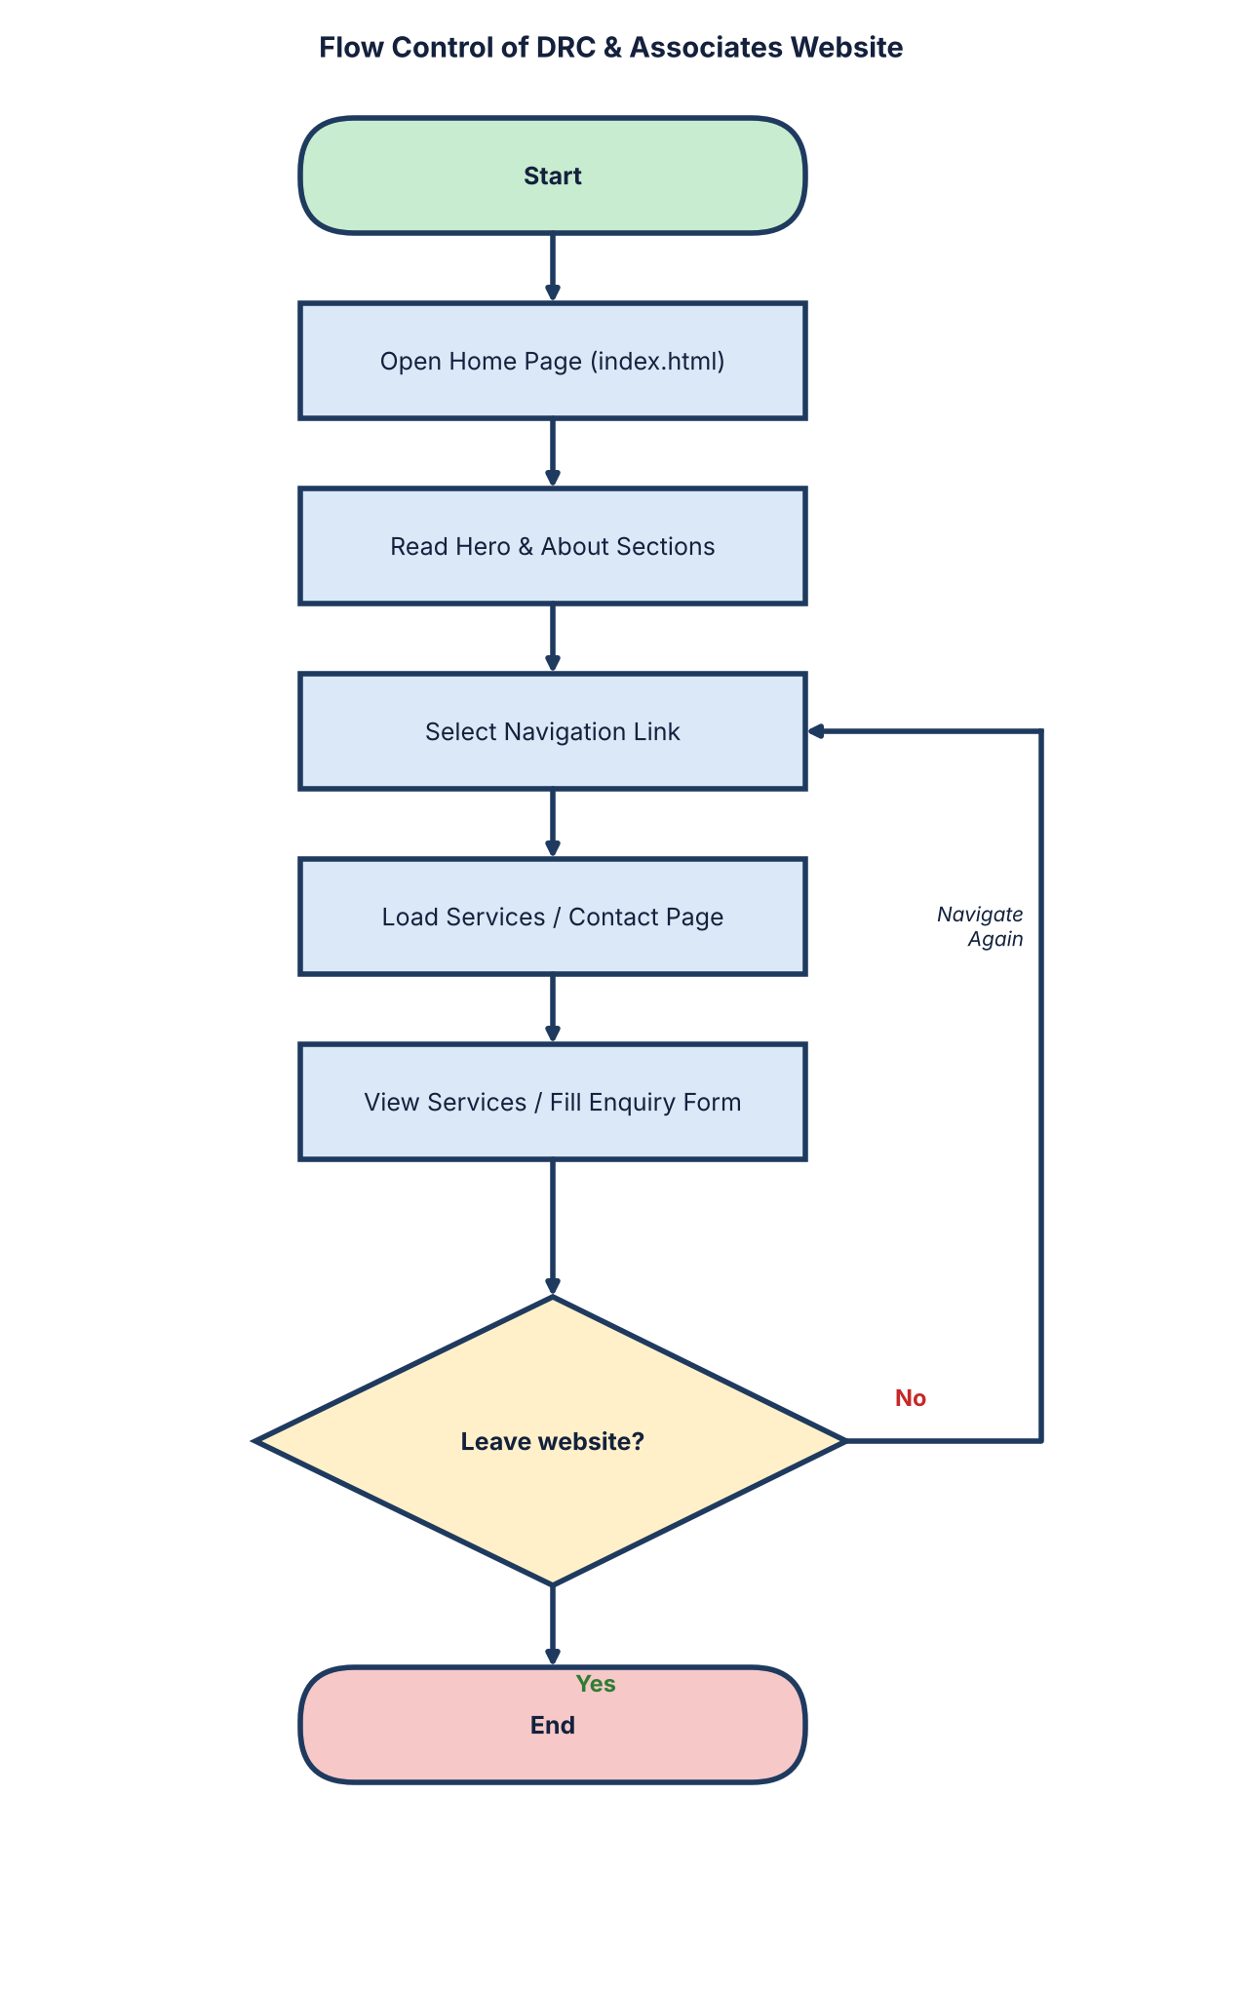

Source Code & Output

The website is built with three HTML pages and one shared CSS file. Snapshots of the main code are shown below; the complete source is available in the project folder.
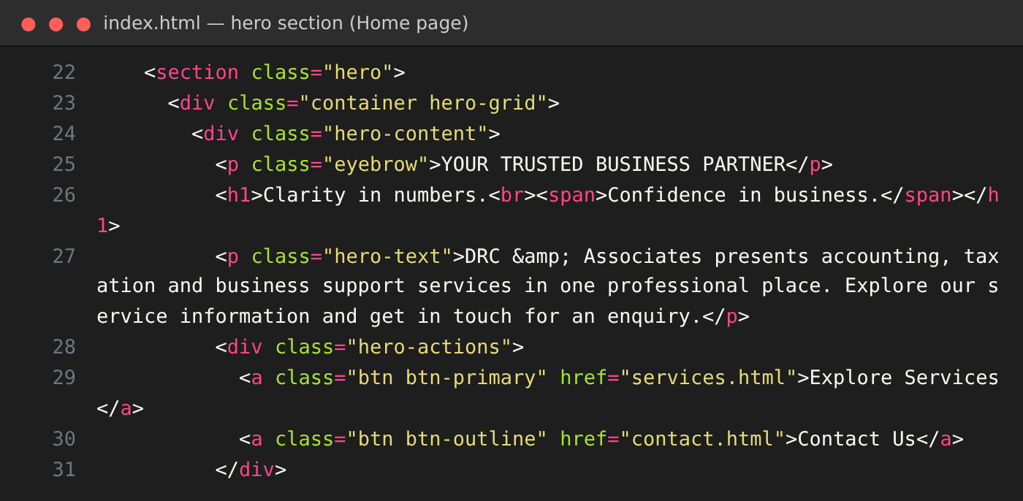
Figure 7.1 index.html – hero section of the Home page
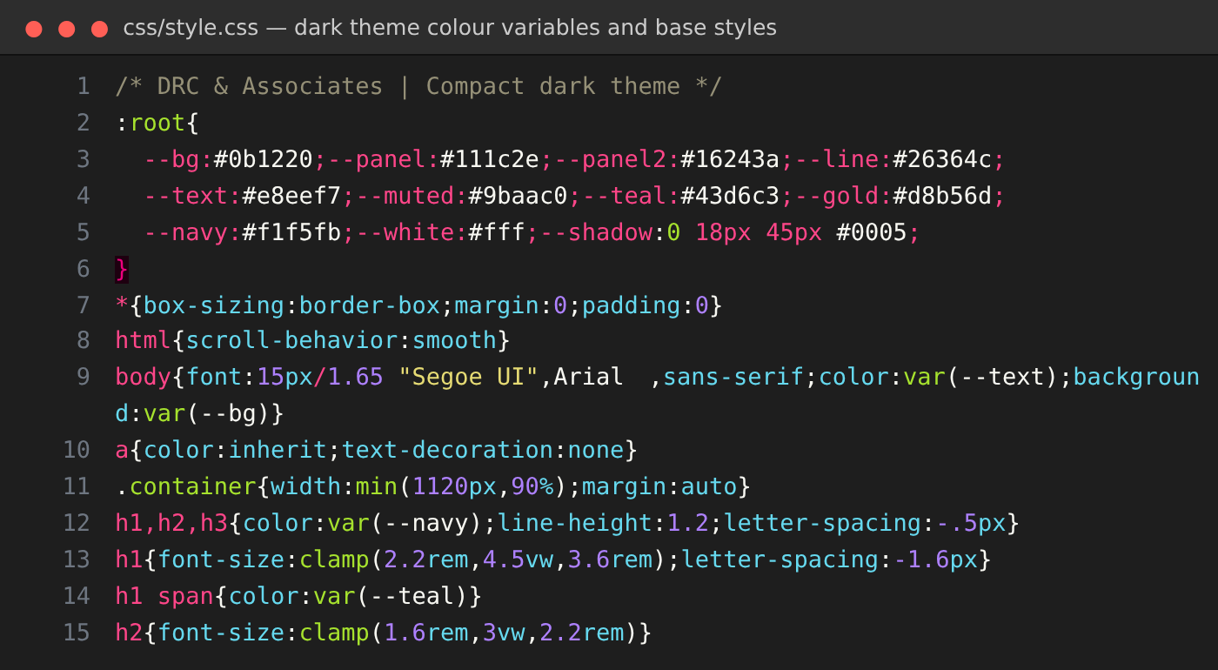
Figure 7.2 css/style.css – dark theme colour variables and base styles

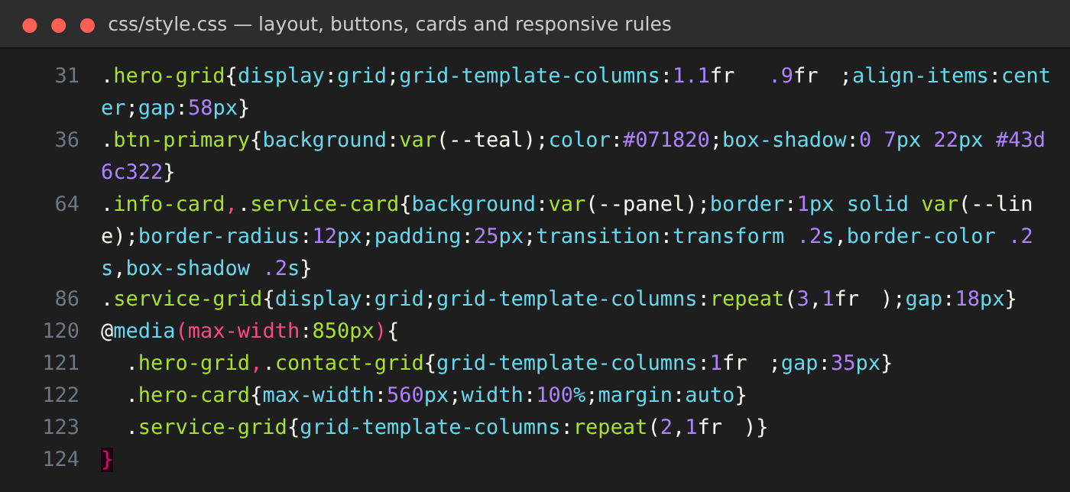
Figure 7.3 css/style.css – layout, buttons, cards and responsive rules
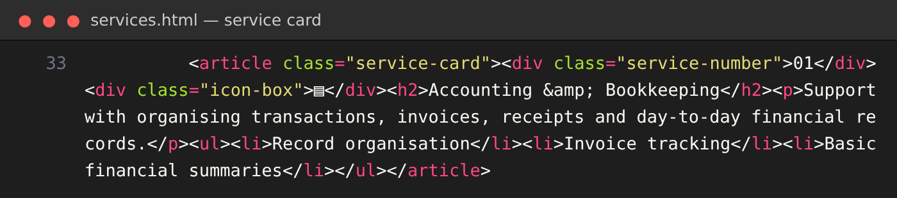
Figure 7.4 services.html – service card markup
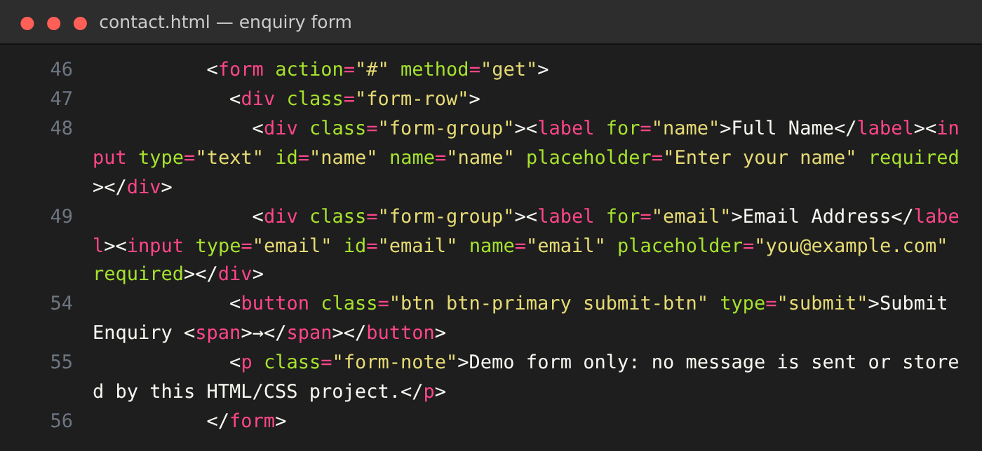
Figure 7.5 contact.html – enquiry form markup

7.1 Sample Output
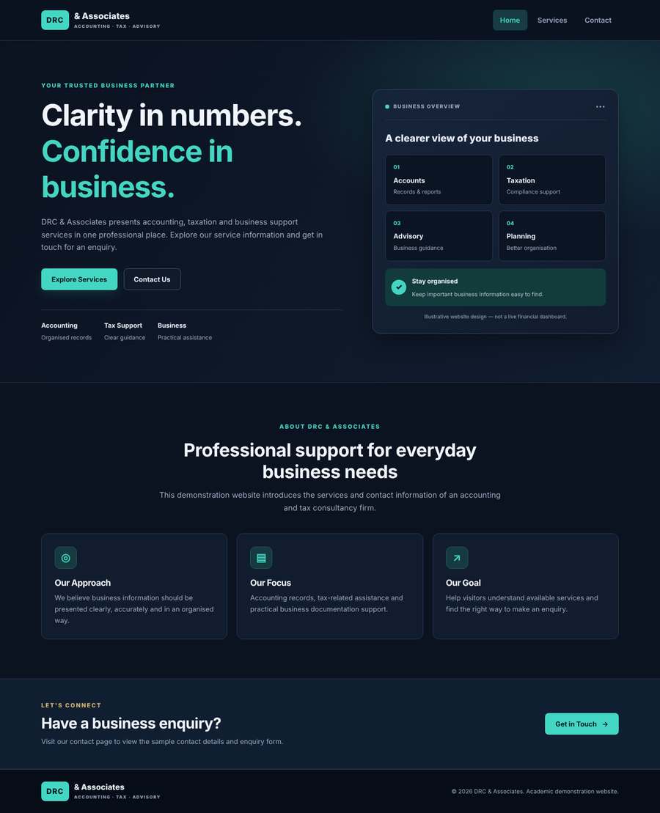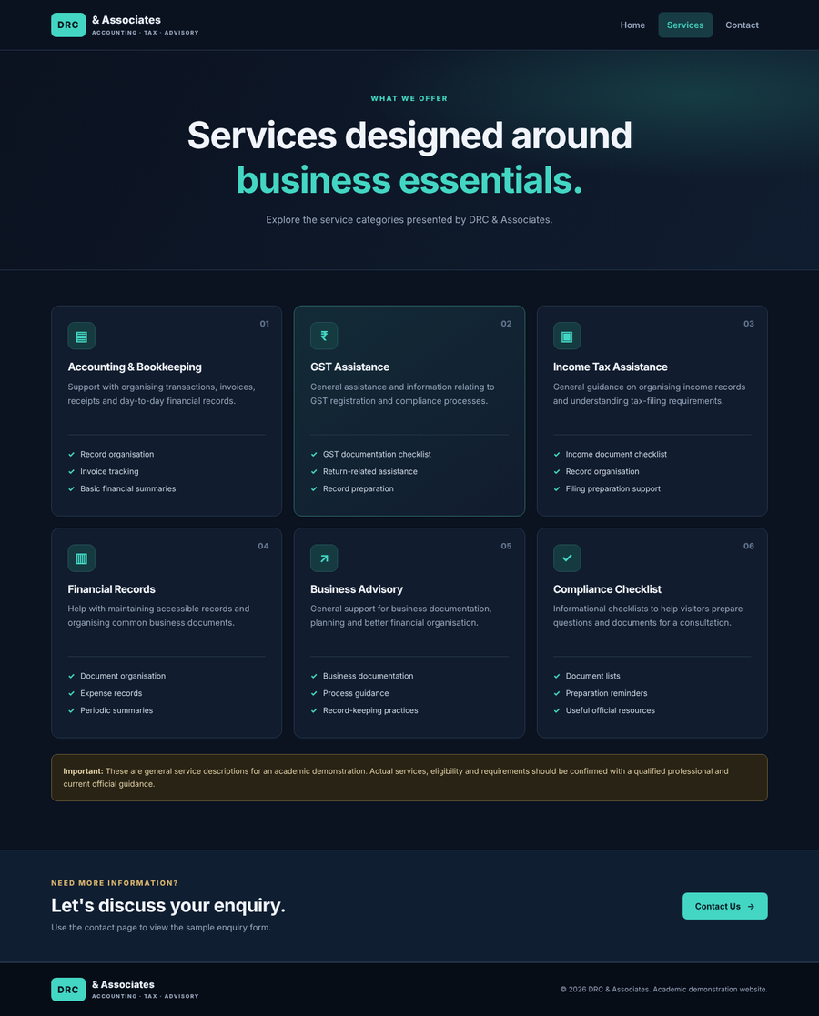
(a) Home page (index.html) (b) Services page (services.html)
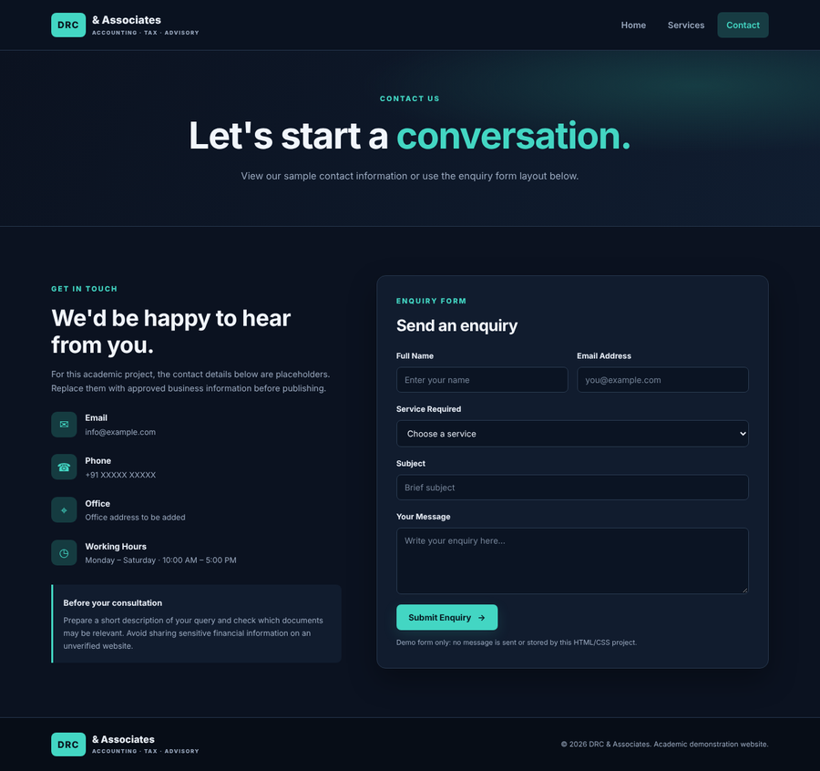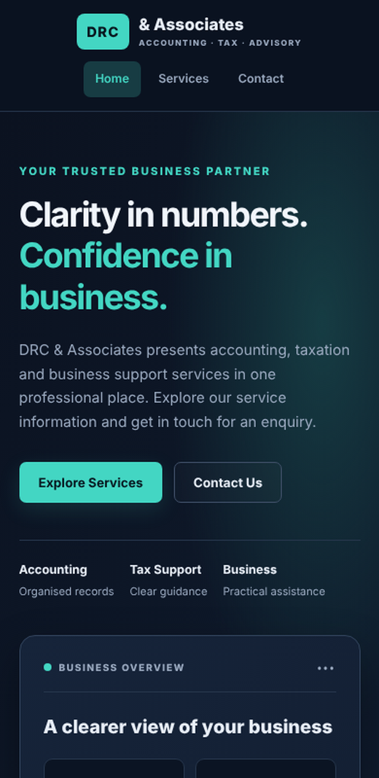
(c) Contact page (contact.html) (d) Mobile view (390 px)

7.2 How to Run the Website
Extract the ZIP file and open the DRC_Associates_Website folder in Visual Studio Code. Open index.html in a browser,
or right-click index.html and choose the following option if the Live Server extension is installed:
Open with Live Server
http://127.0.0.1:5500/index.html
The website runs in the browser. Use the navigation menu to visit Services and Contact. The enquiry form is a demo and does not send or store any data.

8. Functionalities
8.1 Home Page
The Home page shows a sticky navigation bar, a hero section with the heading “Clarity in numbers. Confidence in business.”, a business overview card with four items, an About section with three information cards and a call-to-action banner.

8.2 Services Page
The Services page presents six service cards: Accounting & Bookkeeping, GST Assistance, Income Tax Assistance, Financial Records, Business Advisory and Compliance Checklist. A disclaimer states that the descriptions are general and meant for academic demonstration.

8.3 Contact Page
The Contact page lists placeholder contact details (email, phone, office and working hours), a consultation tip and an enquiry form with name, email, service, subject and message fields.

8.4 Navigation and Dark Theme
A common header links all pages and highlights the active page. The dark theme is controlled by CSS variables such as --bg, --panel, --teal and --gold, so the colours can be changed from one place.

8.5 Responsive Design
Media queries at 850px and 600px change the multi-column grids into two-column and single-column layouts so the website stays readable on tablets and mobile phones.

9. Conclusion
The DRC & Associates website demonstrates how HTML and CSS alone can be used to build a clean, professional, dark-themed multi-page website. It presents the Home, Services and Contact pages through a shared navigation menu, reusable styles and a responsive layout. The project meets its learning objectives and provides practical experience with semantic markup, CSS variables, Flexbox, Grid, forms and media queries.

10. Future Work
          - Add JavaScript for form validation and a toggle menu on mobile devices.
          - Connect the enquiry form to a backend service or email API to receive submissions.
          - Add a light/dark theme switch that remembers the visitor’s choice.
          - Add more pages such as About Us, Team, Blog and FAQ.
          - Replace placeholder contact details with approved information and publish the website online.

11. Learning Outcomes
- Learned how to structure a multi-page website using semantic HTML5.
- Practised styling with CSS variables to create a consistent dark theme.
- Understood how Flexbox and CSS Grid create responsive layouts.
- Learned how media queries adapt a design to tablet and mobile screens.
- Practised building forms with labels, placeholders and required fields.

12. GitHub Link
GitHub repository: https://github.com/Nishantsingh-cyber/web-project.git

